International Council for Mining and Metals
Innovation for Cleaner Safer Vehicles
Greenhouse Gas Emissions Stream
Maturity Framework Self-Assessment “How-To-Guide”

INTRODUCTION
This document is designed to give guidance on the self-assessment process to be used to determine an operation’s status on the Greenhouse Gas (GHG) emissions Maturity Framework.

GREENHOUSE GAS EMISSIONS FOR 2025 – GUIDING PRINCIPLES

Intent of the Maturity Model
The intent of the Maturity Model is to Map, Motivate and Measure the intended status and journey for Greenhouse Gas (GHG) emissions Maturity. In addition, it will drive conversation amongst industry stakeholders to converge thinking, decision making and actions for the most effective use of technology to for eliminating greenhouse gas (GHG) emissions from surface mining fleet by 2040. Key intended outcomes include:

- Enabling member companies to move at their own, industry informed, pace.
- Providing a visual tool to assess progress at a site, company and industry level.
- Outlining an industry landscape on solutions already available or in development.
- Providing clear industry direction for OEMs and 3rd party innovation development.
- Enabling industry leaders to shift towards the ambition quickly (first adopters), bringing along fast followers and ultimately a collective industry shift.

The following is included / excluded in the scope.
- In scope – all surface mining Heavy Mobile Equipment (HME).
- Out of scope - non-fleet alternatives.

The self-assessment only requires you to complete the current state of a site/mine. It will be beneficial for you to plot your desired state to understand where you are, where you want to be and to determine what the gap (next steps) is between these two. For the identified gap between current state and desired state, reference can be made to the ICSV Knowledge Hub on case studies and lessons learnt from other operations.

The completed self-assessments will be collated and analyzed by the ICMM. Aggregated results will be distributed by ICMM among ICSV participants and a one-pager summary will be published in the ICSV Knowledge hub. Results of individual site / mines will be collated by:
- Commodity
- Region

Greenhouse Gas Emissions
Solutions identified by the WG as appropriate to achieve the GHG ambition have been distributed across the different levels of the maturity framework according to their impact. These include:

- Mine design
  - Charging / Fueling Infrastructure
  - Grade-ability changes
  - Road width Impact (Trolley / Truck Size – Maneuverability)
  - Electrical Infrastructure
  - Mining sequence implications
- Fleet Management
  - Green field (new mine)
  - Brown field (existing mine) – mix technology fleets
  - Site dispatch / control systems
  - Non – HME equipment transition

- Technology solutions
  - Increased adoption of existing technologies
Technologies that can reduce GHG emissions in current fleet include:
    - Lower Fuel Consumption per Ton Configurations
    - Increased Bio Fuel Consumption
    - Trolley Assist
    - Anti-idle protocol or Auto Start – Stop
    - Electric Shovel Options (Hydraulic and Rope)
  - New machine designs - Zero GHG Emissions
    - Hybrid – (Engine + Battery) Configurations
    - Battery Powered
    - Hydrogen / Battery Power
    - Trolley Assist
    - Machine size
SELF ASSESSMENT GUIDELINES

Categorization
The categories of the self-assessment ranges from Unaware to Adaptive:
- Unaware – Company is not up to speed on what is happening around new technology developments and the benefits they might bring into the operations and business in general.
- Explanatory – Company is spending more time researching and understanding technologies and adoption requirements and how they can affect the business.
- Defined – Company has a defined strategy and direction; business cases have been developed, KPI defined and potential technology solutions selected. Pilots have been designed and are being implemented.
- Adoptive – Company is in the process of full implementation, with a clear roadmap and strategy. Technologies have been explored with teams, KPI established and risks have been evaluated.
- Adaptive – Company has a very solid understanding of what works and what doesn’t and can make the right decisions. Company is a leader in the industry.

Methodology

1. Level 5 is considered to be the Ambition Level.
2. The requirements of each block should be completely mastered to be considered.
3. For Mine sites: Once the exact stage (Unaware to Adaptive) have been classified for each of the categories under Mine Design and Technology adoption, a line should be drawn to connect each measure point. This is called the “The Current Status”.
4. If the operation can determine the desired level of each category, a line should be drawn to connect each measure point. This is called the “The Desired State”.
5. For the identified gap between current state and desired state, reference can be made to the knowledge hub on case studies and lessons learnt from other operations.
6. For OEMs: In the case of the GHG workstream, OEMs should also try to take the self-assessment, focusing on the category of Technology Development (to determine the industry current status).

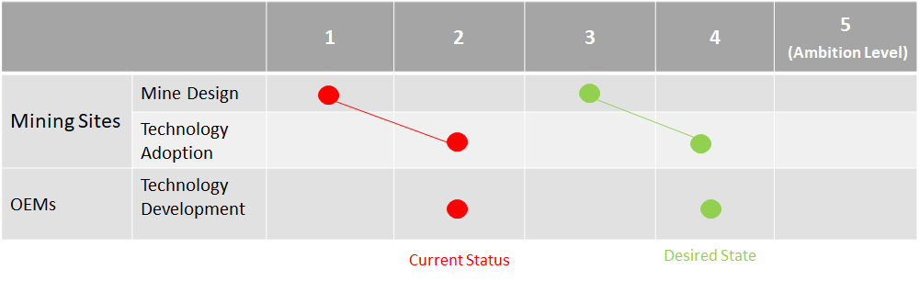

Technical Guidance
Use in conjunction with the GHG Maturity Framework. The requirements of each block should be completely mastered to be considered. Should any of the requirements not be mastered, the compliance level of the block to the left should be used.

Mine Design
Maturity level | 1 | 2 | 3 | 4 | 5
Mine Design Level | Business as usual | Challenge of transitioning to zero emission fleet (ZEF) is understood and analysed. | ZEF adoption strategy defined and a clear path for implementation. | All future mines designed to be fully ZEF. | Fully ZEF in current and future operations.
 |  | Zero emission fleet adoption strategy under preparation. | ZEF partially incorporated into future mine design. | Clean power sourcing available at mine site | Charging/fuelling infrastructure standardized and implemented
 |  | Public commitment made on adoption of ZEF. | Public commitments incorporated into asset plans and budgets.
 |  |  | Public commitment made on adoption rate (e.g. fleet penetration and year).
 |  |  | Business value case for ZEF understood and incorporated into investment evaluation.

Technology Adoption
Maturity level | 1 | 2 | 3 | 4 | 5
Technology Adoption | Focus on optimising efficiency of fossil fuelled vehicles. | Operations select electric options where readily available (e.g. excavators, rope-shovels etc.) | In field demonstrations of smaller ready innovative zero emission vehicles completed or in progress. | In field demonstrations of production ready initial innovative ZEV completed or in progress. | In field demonstrations of production ready ZEV for all equipment categories completed or in progress.
 | Emission driven maintenance | Fleet energy intensity profiles available (consumption on-site by equipment and function) | Fully ZEF operations design understood (existing and future). | Smaller fleet categories of challenging vehicle types still using fossil fuels.
 | Overall data on current fuel consumption available | Understanding of GHG intensity of fleet | Improved/new material movement tasks requirements are defined.
 |  | New material movement tasks are being studied | Hybrid systems adopted in mine sites. | Improved/new material movement tasks are implemented

Technology Development

Maturity level | 1 | 2 | 3 | 4 | 5
Technology Development | No innovative zero emission vehicles being developed. | Hybrid systems (e.g. trolley assist, regenerative energy harvesting, start-stop) available on all major models. | Future ready and easily adopted solutions available (e.g. innovative trolley assist that is low capex and operationally flexible) | Majority of fleet categories available as ZEV | All fleet categories available as ZEV.
 | No fully electric/hybrid options available. | ZEF-optimised vehicle designs underway. | Standardised infrastructure solutions at low cost and low risk | Pilots / proof of concept of ZEV for remainder of equipment categories underway.
 | Additives to improve combustion and lower GHG emissions | Enabling technologies and proof of concepts being developed. | Pilots / proof of concept of initial innovative ZEV completed. | major categories of fleet energy consumption at existing mines now ZEV.
 | Best Available Technology to optimise fossil fuel consumption | Retrofitting alternatives available for current equipments | ZEF for the remainder of equipment categories being developed with completion timelines communicated. | Working with customers to develop ZEF to suit difficult applications.

