ICSV Diesel Particulate Matter
Maturity Framework Self-Assessment “How-To-Guide”

INTRODUCTION
This document is designed to give guidance on the self-assessment process to be used to determine an operation’s status on the Diesel Particulate Matter (DPM) Maturity Framework.
The scope of this work includes underground mobile equipment and associated mine infrastructure, including ventilation. Fixed equipment (e.g. conveyors) and mining methods that do not utilise mobile equipment (e.g. in-situ leaching) are out of scope.

DIESEL PARTICULATE MATTER FOR 2025 – GUIDING PRINCIPLES

Intent of the Maturity Model
The intent of the Maturity Model is to Map, Motivate and Measure the intended status and journey for Diesel Particulate Matter (DPM) Maturity. In addition, it will drive conversation amongst industry stakeholders to converge thinking, decision making and actions for the most effective use of technology to minimise the impacts to underground mining operations from emissions of diesel particulate matter by 2025. Key intended outcomes include:

- Enabling member companies to move at their own, industry informed, pace.
- Providing a visual tool to assess progress at a site, company and industry level.
- Outlining an industry landscape on solutions already available or in development.
- Providing clear industry direction for OEMs and 3rd party innovation development.
- Enabling industry leaders to shift towards the ambition quickly (first adopters), bringing along fast followers and ultimately a collective industry shift.

SELF ASSESSMENT GUIDELINES

Categorization
The categories of the self-assessment ranges from Unaware to Adaptive:
- Unaware – Legislative compliance focused. Local regulation may be basic or lacking.
- Explanatory – Actively investigating the reduction of exposures to DPM through approaches including mine design, ventilation and maintenance.
- Defined – Actively pursuing control of DPM exposure through effective controls and procedures, including optimised ventilation.
- Adoptive – Building on successes at lower maturity levels and improving DPM emissions as far as technologically achievable with a diesel powertrain.
- Adaptive – Implementing widespread use of non-diesel powertrains to eliminate all diesel emissions.

Methodology

- Level 4 is considered to be the Ambition Level, and Level 5 is the stretched target (zero DPM emissions).
- The requirements of each block should be completely mastered to be considered. Should any of the requirements not be mastered, the compliance level of the block to the left should be used.
- Once the exact stage (Unaware to Adaptive) have been classified for each of the categories under Mine Design, Operations and Technology, a line should be drawn to connect each measure point. This is called the “The Current Status”.
- The operation should determine the desired level of each category and a line should be drawn to connect each measure point. This is called the “The Desired State”.
- For the identified gap between current state and desired state, reference can be made to the knowledge hub on case studies and lessons learnt from other operations.
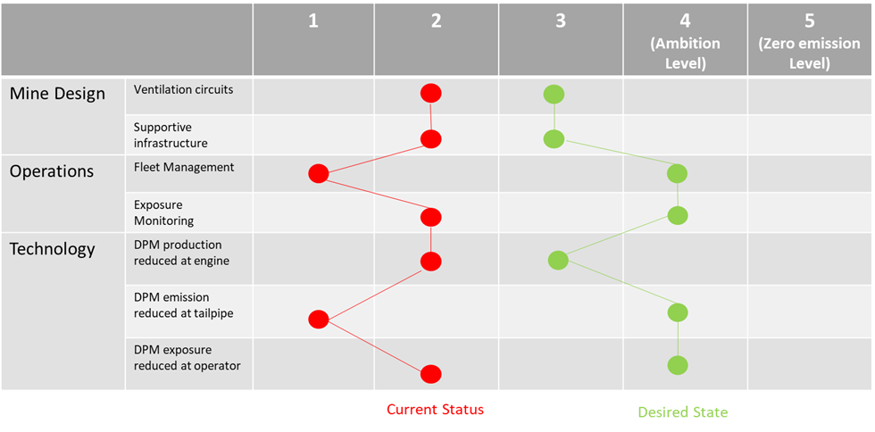

Technical Guidance
Use in conjunction with the DPM Maturity Framework. The requirements of each block should be completely mastered to be considered. Should any of the requirements not be mastered, the compliance level of the block to the left should be used.

Mine Design
 |  | 1 | 2 | 3 | 4 | 5
 |  | Unaware | Exploratory | Defined | Adoptive | Adaptive
Mine Design | Ventilation circuits | -Ventilation rate intended to control acutely toxic gases.  -Mine design allows series Ventilation | - Ad hoc / limited / localised controls in place to reduce DPM exposure.  - Ventilation optimized to dilute DPM as much as feasible  - Mine design emphasizes one-pass ventilation over series ventilation | - Personnel removed from high emission operating areas through remote / autonomous equipment or enclosures with filtered air supply.  - Well designed ventilation system – effective, flexible, and economical.  - Provision for adequate volume flow rate of air required by the mine, and it's satisfactory and economic distribution  -One-pass ventilation is the normal condition in production areas | - Personnel removed from high emission operating areas  - Ventilation is optimized to ensure efficient use of available air volumes and flows with appropriate controls such as ventilation on demand (VOD) | -Ventilation system provides adequate flow to control other hazards (e.g. silica and other mineral dusts, radon, blasting gases, methane, thermal stressors, etc.)
 | Supportive Infrastructure | Infrastructure to support a diesel-powered fleet, without a specific focus on emissions. | -Fuel distribution capable of delivering fuel with <15ppm sulphur  -DPF regeneration equipment  -Low ash lubricants | -Fuel distribution delivering fuel with <15ppm sulphur  -DPF regeneration equipment (as needed)  -Low ash lubricants  Control rooms sealed and ventilated to maintain low DPM levels. | - Charging stations for BEV  - Power distribution system for BEV / trolley / rail  -Fire risk management infrastructure | Infrastructure in place to support widespread use of non-diesel equipment.

Operational Controls
 |  | 1 | 2 | 3 | 4 | 5
 |  | Unaware | Exploratory | Defined | Adoptive | Adaptive
Operational Controls | Fleet Management | No DPM Management Plan (DPMMP) in place | -Diesel Equipment requirements in place  -Education for all personnel on DPM hazards  -Equipment restrictions in place for Primary Ventilation  -Respirators in use to reduce the highest exposures  -Policies discourage idling  -Maintenance practices include emissions testing | -Diesel Equipment requirements audited  -Education for all personnel on DPM hazards and risk mitigation  -HEPA/P100/R3 respiratory protection equipment (RPE) in use above 0.1 mg/m3, and quantitative fit testing conducted  -DPM air concentrations generally controlled below 0.1; RPE only required in upset conditions or similar special cases  -Fleet Management Systems reduce idle time  -Equipment restrictions in place for Primary Ventilation  -Maintenance practices incorporate proactive emissions-driven maintenance program | -Diesel Equipment requirements audited  -Education for all personnel on DPM hazards and risk mitigation  -RPE worn in tasks/areas that exceed company's reduced exposure limit; quantitative fit testing conducted  -Fleet Management Systems reduce idle time  -Equipment restrictions in place for Primary and Secondary Ventilation | Permit system in place to manage short-term UG use of diesel equipment.
 | Exposure Monitoring | No exposure monitoring program in place | Random measurements on diesel equipment and/or areas  Random personal sampling for DPM conducted  DPM levels compared to company standards or local regulations | -Routinely scheduled DPM measurements on diesel equipment and/or areas to guide ventilation practices (e.g. monthly)  -Well developed DPM exposure assessment plan designed to give statistical confidence in exposure level to all UG employees  ->90% compliance to personnel sampling plans  -DPM measurements compared to recommended limit of 0.1 ug/m3 elemental carbon (per NIOSH 5040 method) | -Tailored measurement interval for diesel equipment; targets defined based on Tier ratings of engines in fleet  -essentially 100% compliance to personnel sampling plans for DPM  -DPM measurements compared to company-specific exposure limit, based on risk assessment | Random DPM Sampling to confirm on-going compliance

Technology
 |  | Unaware | Exploratory | Defined | Adoptive | Adaptive
Technology | DPM production reduced at engine | -Powertrains are un-tiered, mechanical diesel engines | Diesel engines replaced or upgraded to meet US EPA Tier 2 or better specifications based on available technologies | -DPM emissions in upstream equipment well controlled through Tier 4 or < Tier 4 with appropriate DPFs  -Specification of Tier 4 engines for new equipment / upgrades | -Tier 4 Final or Euro 5 diesel engines in any location where operators or downstream employees might be exposed  -Non-diesel equipment planned for future expansion and new mines (BEV, fuel cell, trolley, rail etc.). | -Battery electric vehicles  -Trolley for electric-drive equipment  -Electric rail  -Hydrogen fuel cell  -Tethered / trailing cable powered equipment  Permit system actively used to manage exceptions.
 | DPM emission reduced at tailpipe | No tailpipe emission controls | Flow-through filters / diesel oxidation catalyst filters fitted to tailpipes | Diesel Particulate Filter (DPF) installed on diesel-powered equipment used in locations where downstream personnel might be exposed to DPM emissions | Tailpipe aftertreatment, as required to meet specified Tier / Euro rating. | None required for non-diesel powertrains.
 | DPM exposure reduced at operator | Operator compartments are open-cab or have no filtration | Operator compartments have enclosed cabs and low-rated filtration (e.g. MERV-8) | -Enclosed cabs or operator booths with MERV-16 filtration or better and positive pressure relative to operating environment  -Remote or autonomous operation of equipment in high exposure areas | -Enclosed cabs or operator booths with MERV-16 filtration or better and positive pressure relative to operating environment  -Remote or autonomous operation of equipment in high exposure areas | Examples of other hazards:  - silica and other mineral dusts  - radon  - blasting gases  - methane  - thermal stressors

