ICSV Vehicle Interaction
Maturity Framework Self-Assessment “How-To-Guide”

INTRODUCTION
This document is designed to give guidance on the self-assessment process to be used to determine an operation’s status on the Vehicle Interaction (VI) Maturity Framework. It should be noted that this self-assessment is intended to encompass vehicle interaction scenarios in both surface and underground operations.

VEHICLE INTERACTION VISION FOR 2025 – GUIDING PRINCIPLES

Intent of the Maturity Model
The intent of the Maturity Model is to Map, Motivate and Measure the intended status and journey for Vehicle Interaction (VI) Maturity. In addition, it will drive conversation amongst industry stakeholders to converge thinking, decision making and actions for the most effective use of technology to reduce the incidence of unwanted vehicle interactions in mining. Key intended outcomes include:

- Enabling member companies to move at their own, industry informed, pace.
- Providing a visual tool to assess progress at a site, company and industry level.
- Outlining an industry landscape on solutions already available or in development.
- Providing clear industry direction for OEMs and 3rd party innovation development.
- Enabling industry leaders to shift towards the ambition quickly (first adopters), bringing along fast followers and ultimately a collective industry shift.

The following is included / excluded in the scope.
- In scope - Surface and Underground, Vehicle Interaction – Machine to Machine, Machine to Person, Machine to Infrastructure and Loss of Control. The scope also includes all the mobile machines on site, including Light and Medium vehicles. Surface includes any area where vehicles interact and a traffic management plan is implemented.
- Out of scope - Autonomous Vehicles.

Vehicle Interaction Systems

The definition of vehicle interaction system is taken from Earth Moving Equipment Safety Round Table (EMESRT) Performance Requirement (PR) 5A: Vehicle Interaction Systems. (Attached as Appendix A) The objective is to prevent a person or equipment (machine or vehicle) causing an unwanted event in the following four categories resulting in injury or equipment damage: 1) equipment to person, 2) equipment to equipment, 3) equipment to environment, and 4) loss of control of equipment by means of timely, repeatable, dependent and accurate information being presented to a person, the operator or the equipment itself so that appropriate action can be taken by the person, the operator or the equipment itself to avoid or mitigate the outcomes of the above unwanted events.

Understanding of the true intent of the requirements of each of the Levels 1-9 is significant in determining the current and desired states of Vehicle Interaction (VI) Maturity at an operation.

Level 1-6 – Operational Systems Controls
Underlying mine system of operations that may include utilizing technologies that enhance the existing control effectiveness. E.g. fatigue detection

Level 7 – Operator Awareness
Technologies that provide information to enhance the operator ability to observe and understand potential hazards in the vicinity of the equipment
- Ability to provide enhanced situational awareness
- Alerts the operator to a potential abnormal situation
- Provides context of the situation to the operator
  - Where is it?
  - What is it?
  - How far away is it?
  - What is its heading?
  - How fast is it going?
- Supports visual confirmation for the operator

Level 8 – Advisory Controls
Technologies that provide alarms and/or instruction to enhance the operator ability to predict a potential unsafe interaction and the corrective action required
- Determines an imminent threat of collision
- Provides a specific instruction to the Operator to intervene (Act)
- Operator assesses the instruction in relation to other contributing factors then intervenes (Acts)

Level 9 – Intervention Controls
Technologies that automatically intervene and take some form of equipment control to prevent or mitigate an unsafe interaction
- Provides a specific instruction to the Machine to intervene (Act)
- Machine assesses the instruction in relation to other contributing factors then intervenes (Acts)
- Relinquish intervention control to the operator should they take evasive action
- Provides a manual over-ride to recover after a collision intervention scenario has occurred

The mining industry is in the early adoption phase of automation technology. For many reasons including life of mine, economics and social license, many mines will continue to run crewed vehicles. Given that there are going to be staffed mines, then there are four ways to mitigate and/or eliminate unwanted interactions.

- Reduce people from interacting with vehicles. This can be done by careful evaluation of roles and processes which require entry into areas where vehicles are operating. Technologies such as mine cameras and sensing equipment can reduce the occurrence for engineering and operational personnel to enter the operating areas of the mine.
- Mine and road design. There are many reasons why personnel must enter operating area, therefore design and layout of roads and zoning such that interaction with mobile machines is reduced should be a high priority. This reduction can be through dedicated LV roads, improved intersections and investments in tunnels and bridges such as in autonomous operations, one-way traffic and traffic management plans generally.

- Inattention management. Ensuring that people working in the mine are alert and managing fatigue and distractions with process and technology. Fatigue management technology has been available for some years and has shown to be effective at warning of operator fatigue and distraction.
- Vehicle Interaction Systems. The last element is to use technology to prevent unwanted vehicle interaction. It must be emphasized that the first two underlying control layers should be people (reducing roles required to interact with vehicles), process (traffic management) and technology (fatigue and interaction), with technology being the layer when the first two fail.
SELF ASSESSMENT GUIDELINES

Categorization
The categories of the self-assessment ranges from Unaware to Adaptive
- Unaware –The operation has no awareness of vehicle interaction controls. Incidents are avoided through “luck” and not due to effective controls related to vehicle interaction.
- Explanatory –The operation has basic awareness of vehicle interaction related risks and controls. Time is spent on researching to gain more knowledge
- Defined –The operation has awareness of vehicle interaction related risks, implementation of levels 1-6 controls and lower level technology implemented to support 1-6.
- Adoptive –The operation has focused implementation of levels 1-6 controls and higher-level technology implemented to support / replace 1-6.
- Adaptive – The operation has technology integrated systems approach to levels 1-9 to reduce exposure to ALARP

The 5-Stages in the Vehicle Interaction Maturation Pathway

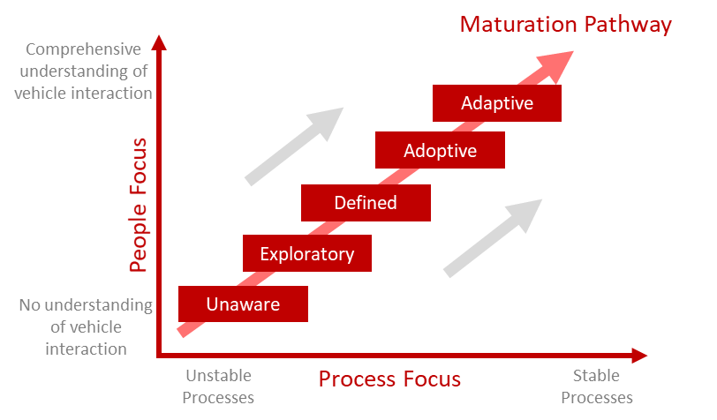
Maturity Framework
The maturity framework is based on the 9-step hierarchal model developed by EMERST
- Levels 1-3 deals with Design Guidelines
  - Level 1 – Site Requirements
  - Level 2 – Segregation Controls
  - Level 3 – Operational Procedures
- Levels 4-6 deals with Operational Discipline Controls
  - Level 4 – Authority to Operate
  - Level 5 – Fitness to Operate
  - Level 6 – Operating Compliance
- Levels 7-9 deals with Vehicle Interaction Technology
  - Level 7 – Operator Awareness
  - Level 8 – Advisory Controls
  - Level 9 – Intervention Controls

Methodology
- The maturity model should be classified from Levels 1-9, in that order
- The requirements of each block should be completely mastered to be considered. Should any of the requirements not be mastered, the compliance level of the block to the left should be used.
- Once the exact stage (Unaware to Adaptive) have been classified for each of the 9 levels a line should be drawn to connect each measure point. This is called the “The Current Status”.
- The operation should determine the desired level of each of the 9 levels and a line should be drawn to connect each measure point. This can be done with a risk assessment. This is called the “The Desired State”
- For the identified gap between current state and desired state, reference can be made to the knowledge hub on case studies and lessons learnt from other operations.
- Plot the required actions for each level to move from current state to desired state and list as the action plan. Your action plan need not be submitted with the completed maturity model.
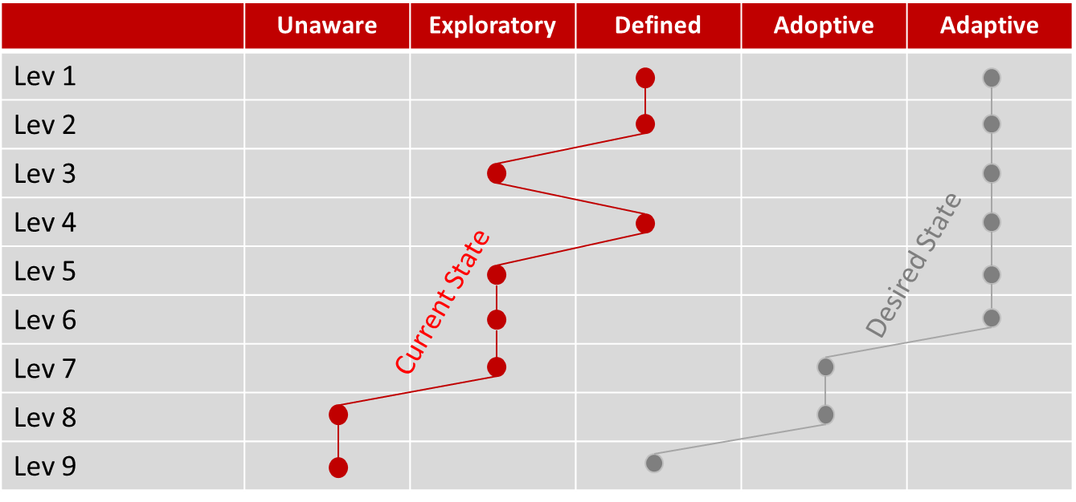
Example
Reference
- The ICSV Information Hub will be available in 2020 for reference purposes, case studies and guidance.

Technical Guidance
Use in conjunction with the VI Maturity Framework. The requirements of each block should be completely mastered to be considered. Should any of the requirements not be mastered, the compliance level of the block to the left should be used.

 |  | 1 | 2 | 3 | 4 | 5
 |  | Unaware | Exploratory | Defined | Adoptive | Adaptative
 |  | Company is primarily focused on legislative compliance with regards vehicle standards and operation. | Company is actively investigating the elimination of vehicle interactions through mine design, operating procedures and engineering controls. | Company is actively pursuing the elimination of vehicle interactions through mine design, operating procedures, monitoring operator behaviour and engineering controls. | Demonstrated success in the adoption of remote and or engineering controls to eliminate vehicle interactions. Coupled with the integrated use of digital data to optimise operational designs and monitoring of work practices. | Implemented leading industry practice in the design of remote and or engineering controls to eliminate vehicle interactions. Coupled with the integrated use of digital data to optimise industry designs and monitoring of work practices.
1. Site Requirements | Equipment Specifications and Standards | - Equipment Specifications and Standards are primarily focused on practicality but in terms of the safety and health of employees consider legislative compliance as a minimum standard. | - Equipment Specifications and Standards are focused on the safety and health of employees, based on legislative compliance as a minimum, and include ad-hoc VI controls and standards. | - Vehicle interaction is identified as a critical hazard with the company having defined administrative, engineering and design standards that considered VI controls. | - Vehicle interaction is identified as a critical hazard with the company actively integrating all levels of control to eliminate the risk. | - Vehicle interaction is identified as a key critical hazard with the company actively integrating all levels of control to exceed industry leading practices.
 | Mine Design | - VI requirements not considered in mine design | - Ad-hoc references to VI requirements in Mine design and planning | - VI requirements considered in Mine design and planning of new projects but not in existing operations | - VI requirements are actively pursued in all mine design and planning processes | - Actively integrates learning from levels 1-9 into mine designs and planning, retrofitting VI principles to existing operations
2. Segregation Controls | Berms, Access control, Segregation of roadways, Time schedule | - Two-way traffic.  - HME and LVs use the same roads. Traffic management plans do not consider hazards and risks associated with vehicle interaction.  - Time schedules not considered. Traffic incidents not analysed to identify potential traffic management weaknesses | - Two-way traffic.  - HME and LVs use the same roads.  - Time schedules to segregate / ease traffic is being considered. Accidents / incident data available but not actively analysed. Several crossings in place | - Two-way traffic,  - HME and LVs segregated.  - Effective berms, access control, segregation of roadways, time schedules implemented. Incident data is used to remove risks in active mine area.  - Crossing being replaced with T-junctions | - One-way traffic  - HME and LV equipment segregated.  - Active management of high-risk areas.  - No crossings, only T-junctions. Active data management | - One-way traffic  - HME and LV equipment fully segregated, crossings replaced with bridges.  - Real time management of high-risk areas with live data streaming
3. Operating Procedures | SOP’s, maintenance, road rules, quality control, lockout, etc. | - Only basic level operating procedures and maintenance are in place.  - No consideration of technological advances to improve operational or engineering controls | - Basic level operating procedures and maintenance are in place  - Technological advances to improve operational controls are being considered | - Operating procedures and maintenance are in line with VI requirements.  - Effective traffic management plans in place | - Operating procedures and maintenance are in line with VI requirements.  - KPI's that drive maturity in place  - Traffic management analysed, and improvements made to layouts | - Operating procedures and maintenance are in line with VI requirements.  - KPI's that drive maturity in place.  - Real time traffic monitoring in place  - Critical control monitoring is in place
4. Authority to Operate | Training, licences, induction, access control | - Basic level of authority to operate exists only to meet minimum legal requirements | - Basic level of authority to operate exists, mostly manual systems and enforcement is consistent.  - Limited training and assessment | - High quality training and assessment are in place to ensure operators are competent.  - Engineering control for Primary mobile equipment in place | - Control systems are in place that integrates the authority to operate process with engineering controls to eliminate the opportunity for failure.  - High quality training and assessment are in place to ensure operators are competent. | - Control systems are in place that automates engineering controls to eliminate the opportunity for failure.  - Advanced training and assessment are in place using data feedback from Levels 7 - 9 combined with technologies such as virtual reality.
5. Fitness to Operate | Fatigue state, drug & alcohol, medicals | - Basic levels of fitness to operate exists with inconsistent level of application.  - Drug and Alcohol testing is conducted for causation only. | - Basic levels of fitness to operate exists with consistent application.  - Ad-hoc drug and alcohol testing is conducted.  - Ad-hoc medicals conduced with no specified medical limitations | - Routine alcohol and drug testing in place.  - Engineering controls implemented for real time fatigue monitoring.  - Fitness for work training and awareness campaigns in place. | - Automated alcohol testing as part of the access procedure, with periodic drug screening.  - Engineering controls implemented for real time fatigue monitoring with automated escalation. | - Automated alcohol testing as part of the access procedure, with periodic drug screening.  - Engineering controls implemented for real time fatigue monitoring with automated escalation.  - Integrated systems to allow trending and analytics as a lead indicator, with proactive training and interventions.
6. Operating Compliance | Pre‐start, safety tests, machine health, event recordings | - Minimal operating procedures in place.  - Low levels of socialisation of procedures within the operation.  - No formal maintenance and pre-start systems in place. | - Robust operational procedures but not well socialised and consistently enforced.  - Basic maintenance and pre-start process that is auditable but does not have a continuous improvement process in place. | - Robust operational procedures that are well socialised and consistently enforced.  - Mature maintenance and pre-start process that is auditable and has a continuous improvement process in place. | - Robust operational procedures that are well socialised and consistently enforced.  - Integrated controls to manage pre-starts and safety checks fully implemented.  - Closed loop feedback from levels 7 - 9 are used as an input to into training, continuous improvement and maintenance programs. | - Engineering or higher order controls to automate and integrate pre-starts and safety checks fully implemented.  - Real time monitoring and escalation of operator behaviour and machine health.  - Advanced training and assessment in place using data feedback from vehicle telemetry, combined with technologies such as virtual reality.
7. Operator Awareness | Cameras, live maps, mirrors, lights, visible delineators | - Vehicles operate in basic form i.e. as supplied.  - No additional technological controls implemented to improve operator awareness e.g. Cameras, live maps, mirrors, lights, visible delineators. | - Vehicles operate in basic form i.e. as supplied.  - Additional technological controls to improve operator awareness and to provide additional context to the operator are being researched and considered | - Additional technological controls to improve operator awareness, warning operator of a potential abnormal situation and to provide additional context to the operator have been concluded, pilot sites been identified, and an implementation plan defined. | - A full suite of operator awareness controls (Appropriate to the site, vehicle and conditions) are implemented that provide information to enhance the operator ability to observe and understand potential hazards in the vicinity of the machine | - A full suite of operator context and awareness controls are implemented  - Real-time maps and monitoring in place.  - Operators warned of any potential abnormal situation
8. Advisory Controls | Alerts: Proximity, Fatigue, Over‐speed, Vehicle stability | - Vehicles operate in basic form i.e. as supplied. No additional technological controls implemented to monitor fatigue, over speeding, proximity or stability. | - Vehicles operate in basic form i.e. as supplied.  - Additional technological controls considered but not yet implemented e.g. fatigue monitoring, over speeding, proximity or stability | - Technological controls for vehicle to determine imminent threat of collision have been identified and a company strategy in place to further implementation of this stage.  - Adoption plan is in defined for technology that will be implemented | - Technological controls for vehicle to determine imminent threat of collision and provide relevant information to the operator have been identified and implemented e.g. fatigue levels, over speeding, proximity of other vehicles and vehicle stability.  - This technology will provide the operator with specific actions on how to intervene. Operator will assess information and determine action before intervening. | Full implementation of integrated fatigue levels awareness which includes:  - Over speeding,  - Proximity of vehicle to vehicle, vehicle to person and vehicle to other  - Vehicle stability.
9. Intervention Controls | Interlocks: Prevent Start, Slow‐Stop, Rollback, Retarder | - Vehicles operate in basic form i.e. as supplied.  - No additional technological controls implemented to automatically intervene and take some  form of machine control to prevent or mitigate an unsafe interaction | - Vehicles operate in basic form i.e. as supplied.  - Additional technological controls for the vehicle to automatically intervene to prevent or mitigate an unsafe interaction are being considered but not yet implemented. | - Potential intervention technologies have been identified and is being researched.  - Adoption plan is in defined for technology that will be implemented | Intervention technologies have been identified and an implementation plan is in place:  - Machine to assess the situation based on information received from technology and then react.  - Machine to relinquish control to the operator should the operator take evasive action  - A manual override is required to override after collision intervention scenario has occurred | - Full implementation of Technologies that automatically intervene and take some form of machine control to prevent or mitigate an unsafe interaction e.g. retard and stop.  - The operator is removed from the risk (e.g. tele remote)

SELF ASSESSMENT DATA

Capturing
Information will be captured on the Maturity Framework Self-Assessment Version XYZ (Appendix B). Self-assessments will be submitted on a company level and not operation level. Should the company have multiple Commodities, Countries, or Surface and Underground operations, it is requested that separate submissions be made. It is advisable to complete a self-assessment per operation and use the aggregate scores for the group level / commodity level self-assessment.

Submission of data
The completed self-assessment will be forwarded to someone.tobeconfirmed@iccm.com once completed.

Collation of data
The completed self-assessments will be collated and analyzed by the ICMM. Results will be published on the ICMM data portal, as well as in the ICSV Knowledge hub. Results will be collated in:
- Commodity
- Country
- Surface and Underground separately

